Login Activity Diagram:
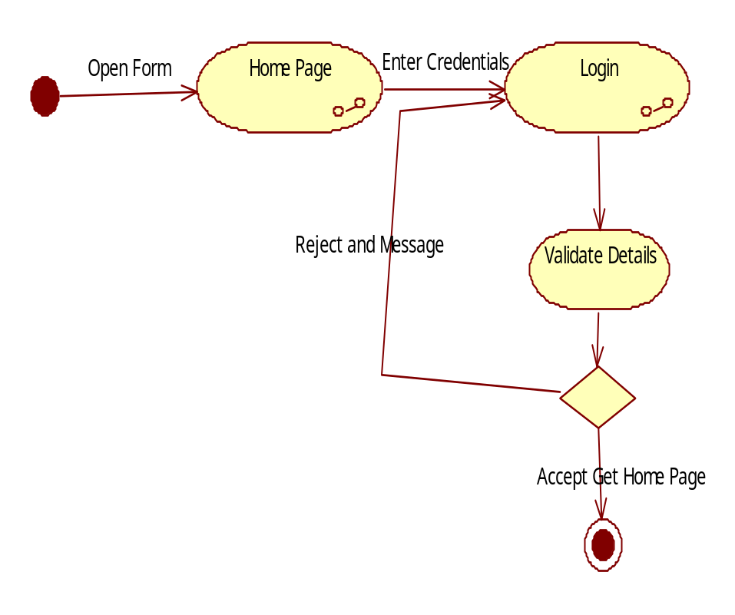

Admin activity Diagram:
Home Page
Login
Enter Credentials
Validate Details
NO
Yes
Add State
Add District
Add City
Add Distributors
Add Cylinders
View feedback, Reports
View Requests

Distributor Activity Diagram:
Home Page
Login
Enter Credentials
Validate Details
NO
Yes
Update Profile
View User New Connection Request
View Gas Booking Requests
Send Feed Back
View Reports

Consumer Activity Diagram:
Home Page
Login
Enter Credentials
Validate Details
NO
Yes
Update Profile
View Gas Card Details

Make Online Gas Booking Requests
View Request Status
Send Feedback

